# **Copilot**

Is an autocomplete-style suggestions from an AI pair programmer as you code.

<https://docs.github.com/en/copilot>

## **How to start**

1. Have an active GitHub Copilot subscription:
   * Get it from: <https://github.com/features/copilot/>
   * Detailed explanation: <https://docs.github.com/en/billing/managing-billing-for-github-copilot/about-billing-for-github-copilot>
2. Install VS Code (if not already):
   * <https://code.visualstudio.com/Download>
3. Install VS Code extension:
   * Install GitHub Copilot extension: <https://marketplace.visualstudio.com/items?itemName=GitHub.copilot>
   * Login with GitHub, approve permissions, connect to GitHub copilot.
   * Reload editor.
4. Seeing suggestions:
   * To accept the suggestion, press *Tab*. To reject all suggestions, press *Esc*.
   * Optionally, you can see alternative suggestions if any are available.
     + Windows/Linux: *Alt*+] and *Alt*+[
     + maxOS: *Option* (⌥) or *Alt*+] and *Option* (⌥) or *Alt*+[
   * Alternatively, you can hover over the suggestion to see the GitHub Copilot command palette for choosing suggestions.

**Full step-by-step description:**<https://docs.github.com/en/copilot/getting-started-with-github-copilot?tool=vscode>

## [**Enabling or disabling duplication detection**](https://docs.github.com/en/copilot/configuring-github-copilot/configuring-github-copilot-settings-on-githubcom#enabling-or-disabling-duplication-detection)

GitHub Copilot includes a filter which detects code suggestions matching public code on GitHub: [https://docs.github.com/en/copilot/configuring-github-copilot/  
configuring-github-copilot-settings-on-githubcom#enabling-or-disabling-duplication-detection](https://docs.github.com/en/copilot/configuring-github-copilot/configuring-github-copilot-settings-on-githubcom#enabling-or-disabling-duplication-detection)

## **Copilot works best if we:**

* Divide code into small functions.
* Use meaningful names for functions, variables, and parameters.
* Write good docstrings and comments as you go.

## **Use cases:**

* Generate user-defined functions.
* Generate documentation.
* Generate test cases.
* Generate standard functions (sort, find, connect, …)
* Code improvement/refactoring.
* Contextual text improvement (no code).
* Translate/use other programming languages.
* Navigate unfamiliar libraries or frameworks.
* Avoid some mistakes, forget steps or conditions, or simple to explore new/different code options.

## [**Real**](https://docs.github.com/en/copilot/configuring-github-copilot/configuring-github-copilot-settings-on-githubcom#enabling-or-disabling-duplication-detection) **examples of suggestions**

The following collection of images were taken with real (personal) codes. In grey are the Copilot suggestions for each case.

## Entire functions created with Copilot after some code is in place.

## Code created with Copilot just with the initial comments to explore the FastAPI Framework.

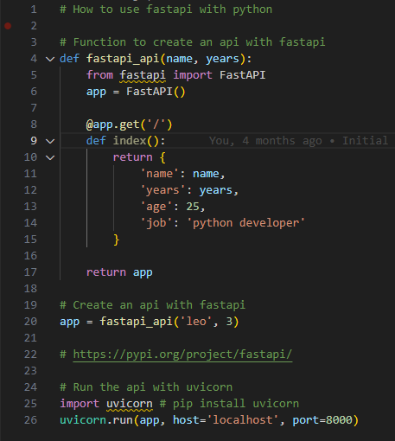

## Function entirely created with Copilot just with the three comments and the function name.

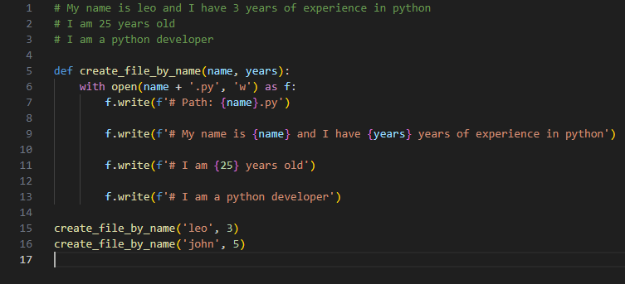

## Some examples with Trigonometry, all are right answers.

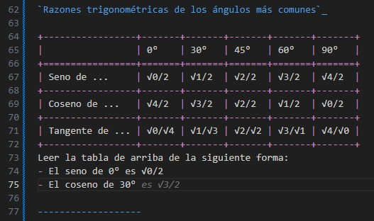

## More complex suggestions based on code around:

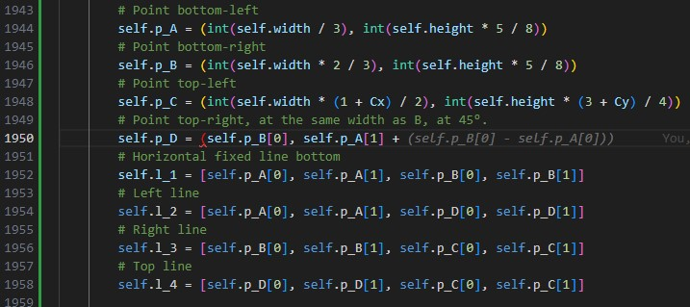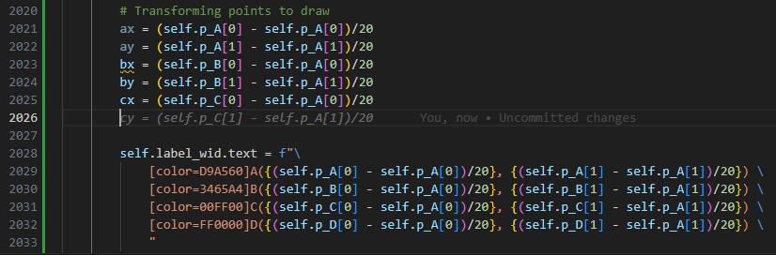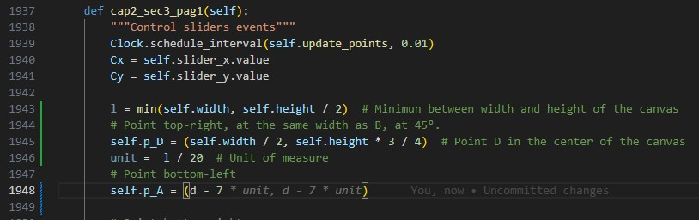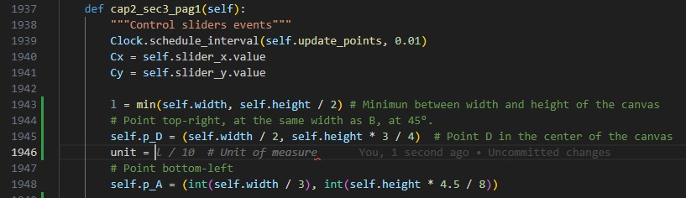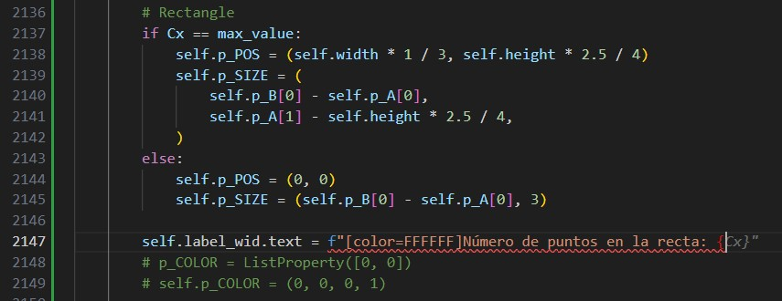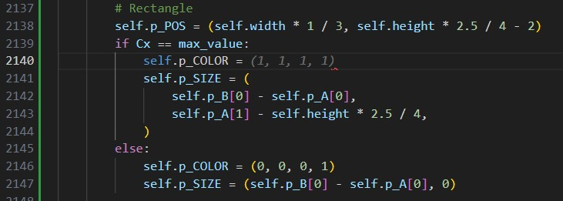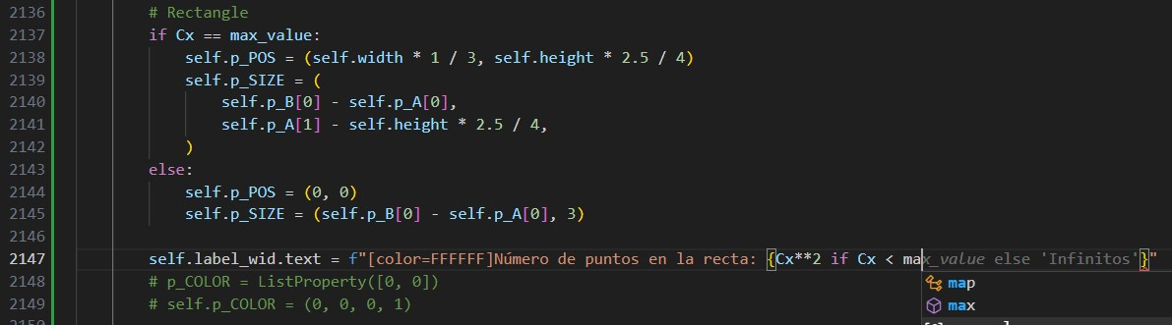

## This was true! The variable self.l_5 was for override the horizontal mobile line l_1

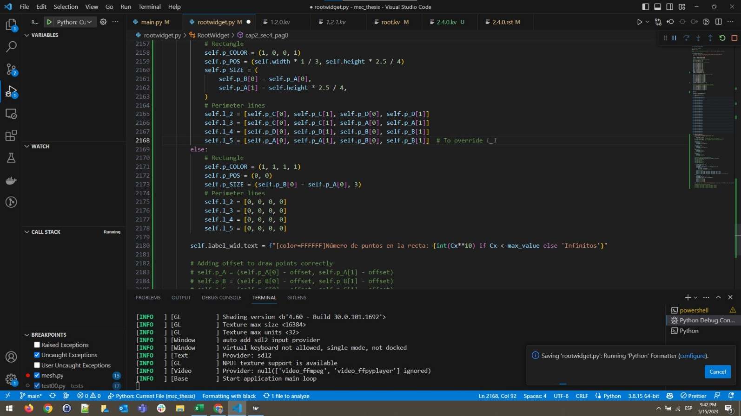

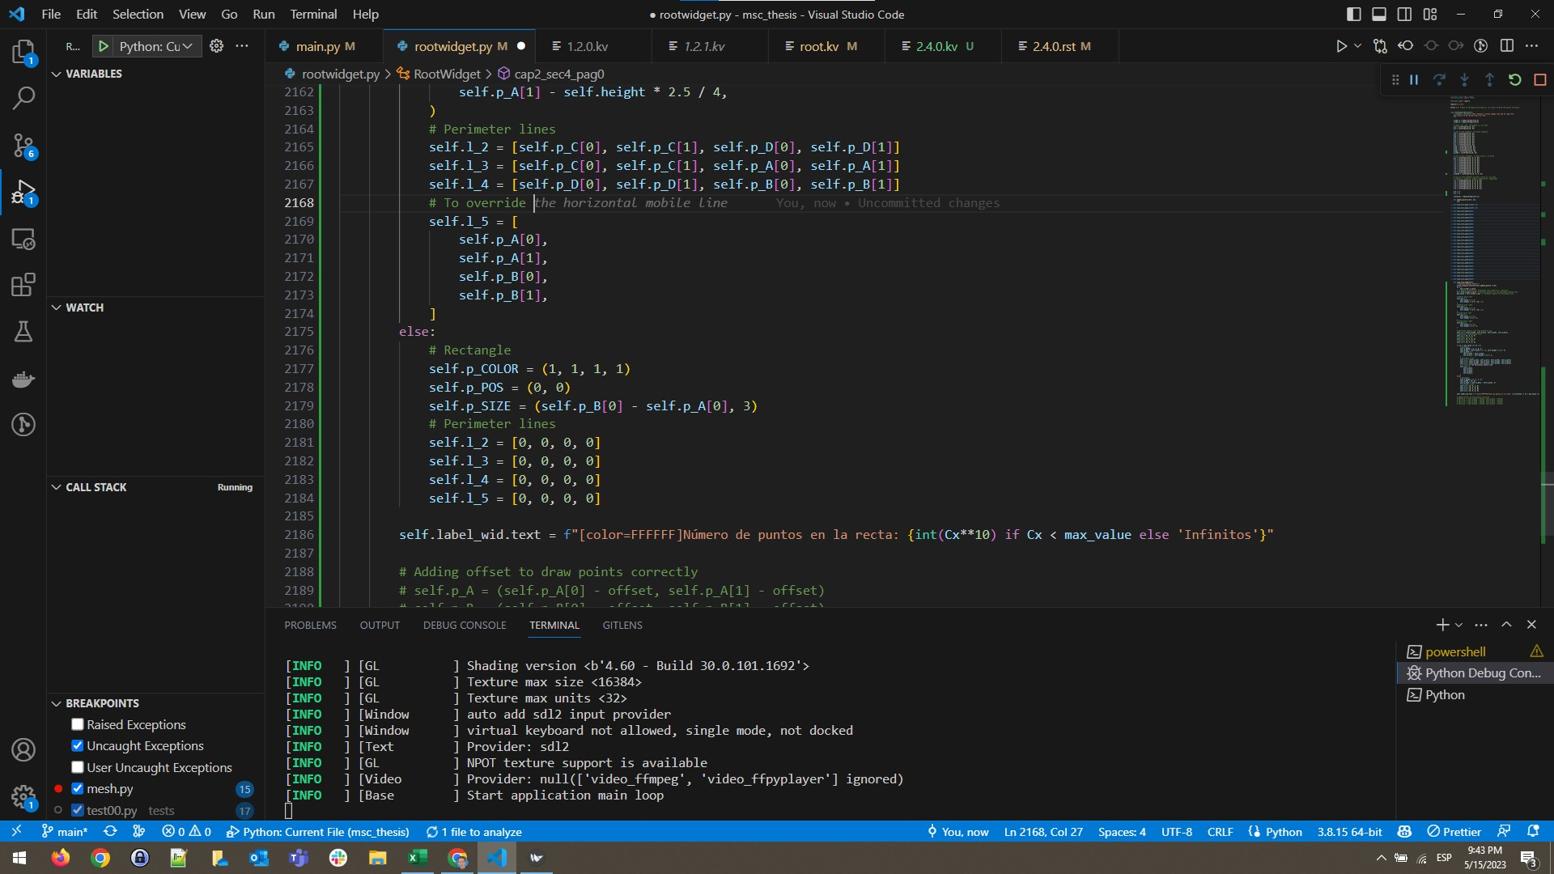

## More complex suggestions based on code around:

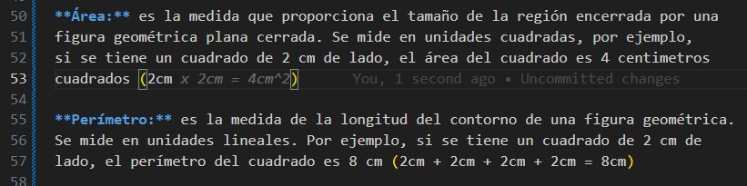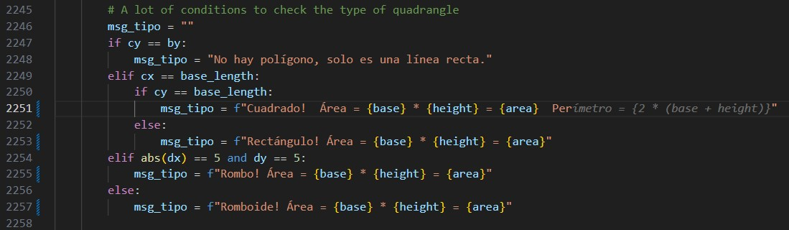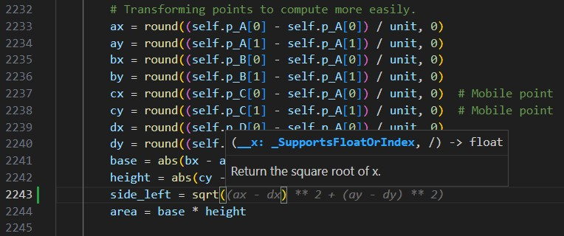

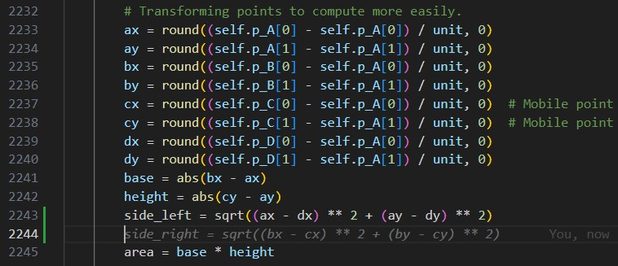

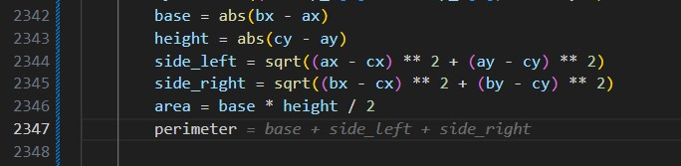

## Correct logic suggestions based on the previous code!

## All this code was generated automatically, and it was correct!

